Scheduling 2nd Vaccination Bookings on the Simplybook Booking Platform
To support the Covid-19 vaccination delivery
Contents
1 Definition and Purpose 3
2 Making a 2nd Vaccination Appointment 3
2.1 Checking the Validation Status of the current booking 3
2.2 Making a 2nd Appointment 3

- Definition and Purpose
This booklet sets out the operational processes for making 2nd Vaccination bookings, on the JBS Booking Platform.
Should you not be able to find the support you require within this document, please contact the jbs.enquiries@miaa.nhs.uk mailbox, where one of the team will be able to assist.
- Making a 2nd Vaccination Appointment
  - Checking the Validation Status of the current booking
For users with POS access and above
Before making a follow up appointment, it is necessary to check that the first appointment was ‘validated’.
Open your Simplybook account from the admin interface (using a website link).
Select Calendar from the sidebar menu, and then Validate Ticket.
Enter the ticket number (or scan using a QR code readable scanner) into the search bar, and click ‘Find Ticket’
Scroll to the bottom of the screen, where the booking details will appear. If a ticket has already been validated there will not be an option to ‘Validate Ticket’. If a ticket has not been Validated, click ‘Validate Ticket’

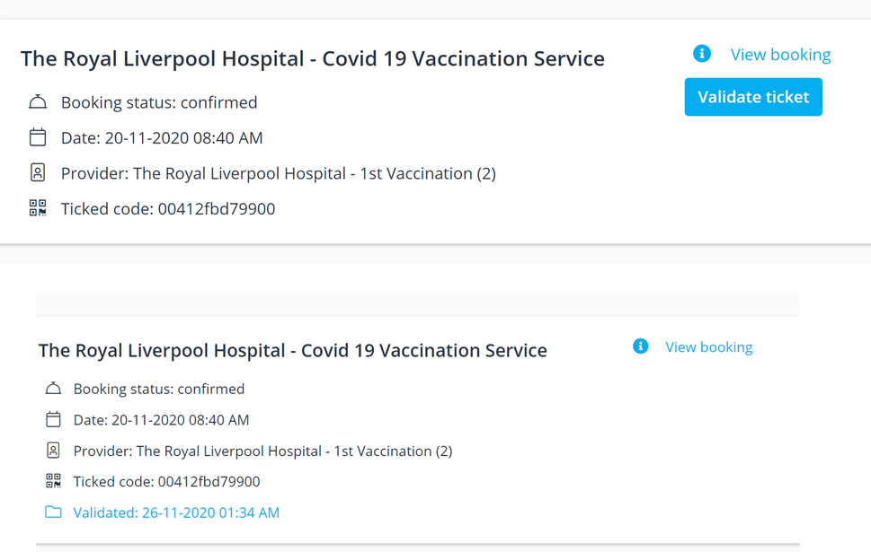

  - Making a 2nd Appointment
For users with POS access and above
Follow step 2.1 first.
Select Calendar from the sidebar menu, and then Validate Ticket.
Enter the booking code (or scan ticket QR code) in to the search bar
Click ‘Find Ticket’
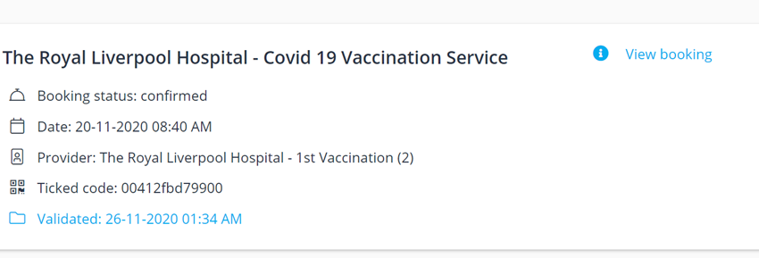
Click ‘View Booking’ and scroll to the bottom.
Click ‘Rebook’
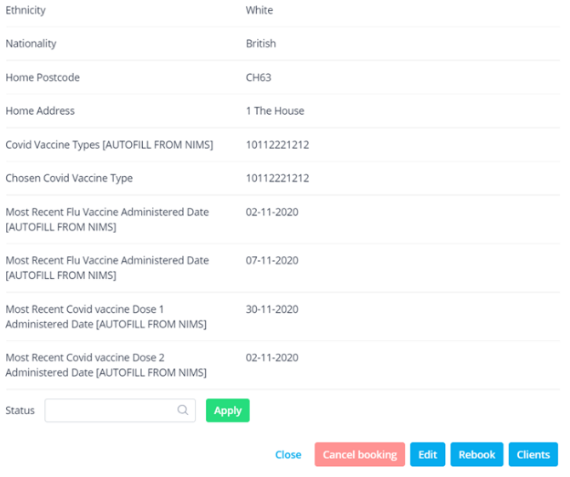

Change the Service Provider to a ‘2nd vaccination’ vaccination lane.
Enter a date set for the correct time delay – this will be determined by the vaccine type the user has just received.
Enter a appointment start time
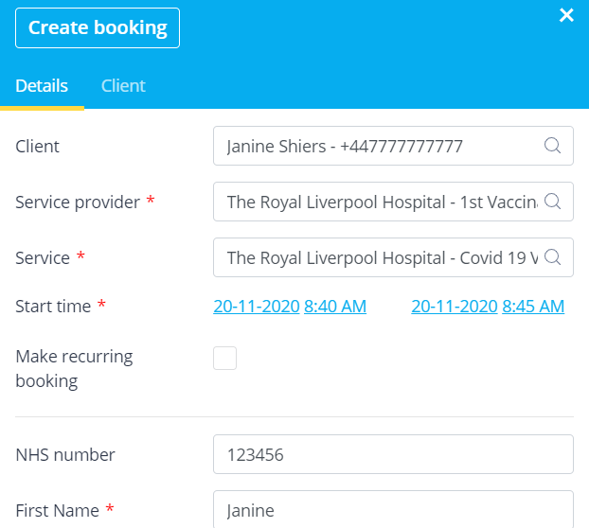
Click ‘Save’ (*If the selected date, and or time is not available, and error message will appear)

